Patel's Analog and Digital Measurement Co. Pvt. Ltd,
A/6 Functional Electronic Estate, Bhosari Indl. Area, Pune- 411026.
Tele: (020) 27120290/ 27120324, Fax: (020) 27122043
E-mail: padmco@vsnl.net , Arleen@dataone.in
_________________________________________________________________________________________________
Inquiry Form- Hairpin or R -Shape Conductor taping machine
Please provide the requested information:
If engineering drawings are available, please send these with your enquiry.
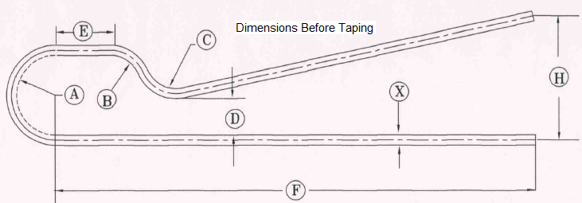
R shape Bushing Type  (KV) –If known | Dimensions Before Taping  (mm) | Dimensions After Taping  (mm)
 | A | A
 | B | B
 | C | C
 | D | D
 | E | E
 | F | F
 | H | H
 | X | X
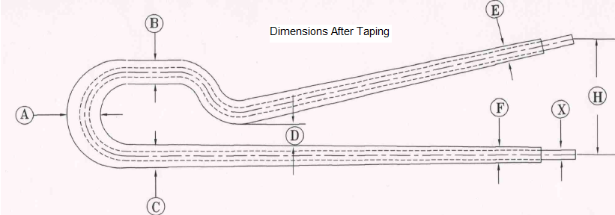
Please fill your following information
Company name :
Company website, :
Company E-mail ID :
Company Contact No.

